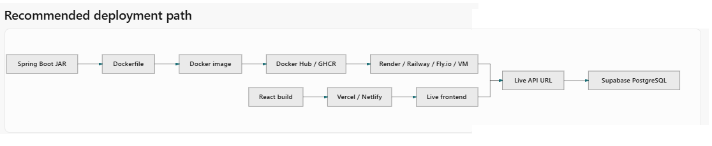
NOTE : put all the supabase credentials in application-local.properties and add it to the .gitnore file so that it is not pushed coz git will not allow to push files containing secrets

.Gitignore
HELP.md
target/
.mvn/wrapper/maven-wrapper.jar
!**/src/main/**/target/
!**/src/test/**/target/

# Ignore local environment properties with secrets
**/application-local.properties
application-local.properties
**/application-*.properties

application-local.properties

Application-local.properties

# PostgreSQL via Supabase Session Pooler (IPv4-friendly)
spring.application.name=ITPJan2026Springboot
server.port=8085

spring.datasource.driver-class-name=org.postgresql.Driver
spring.datasource.url=jdbc:postgresql://aws-0-ap-southeast-1.pooler.supabase.com:5432/postgres?sslmode=require
spring.datasource.username=postgres.ylvamnubisxnkydxkxzk
spring.datasource.password=Madhupranshu@123

spring.datasource.hikari.maximum-pool-size=5
spring.datasource.hikari.connection-timeout=30000

spring.jpa.properties.hibernate.dialect=org.hibernate.dialect.PostgreSQLDialect
spring.jpa.properties.hibernate.format_sql=true
spring.jpa.show-sql=true
spring.jpa.hibernate.ddl-auto=update

# Supabase Auth / API
supabase.url=https://ylvamnubisxnkydxkxzk.supabase.co
supabase.publishable-key=sb_publishable_ogJ4TeLWqgi0tAuOonaL3g_mByDKABZ
supabase.secret-key=sb_secret_ABNbENyPtrOFpiFk6OYhYQ_D9l9mvv8
supabase.jwks-url=https://ylvamnubisxnkydxkxzk.supabase.co/auth/v1/.well-known/jwks.json

NOTE : No, you should NOT set spring.profiles.active=local inside application.properties.
If you put spring.profiles.active=local in application.properties, Spring Boot will always try to look for application-local.properties everywhere—including on Render, Railway, or inside your Docker container (where application-local.properties will not exist because it is ignored by Git).

NOTE : to run localy
-Dspring.profiles.active=local

How to activate the local profile on your machine ONLY
You activate the profile when running the app locally in Eclipse or Terminal—not inside the committed properties file:
- In Eclipse: Run Configurations → Spring Boot App (or Java Application) → Arguments tab → VM arguments:
-Dspring.profiles.active=local

Or via Terminal / PowerShell:
java -jar -Dspring.profiles.active=local target/ITPJan2026Springboot-0.0.1-SNAPSHOT.jar

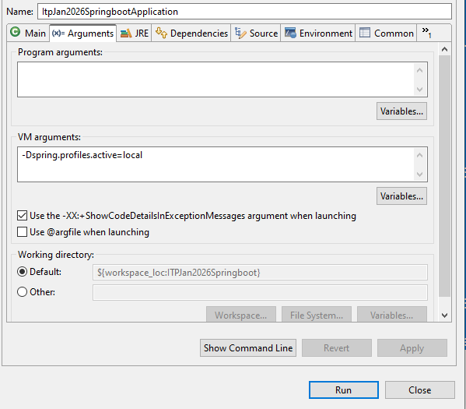

DockerFile

FROM eclipse-temurin:17-jre
WORKDIR /app
COPY target/*.jar app.jar
EXPOSE 8085
ENTRYPOINT ["java", "-jar", "app.jar"]

NOTE : Docker tags and image repository names in ghcr.io must be completely lowercase

Build.yml

name: Spring Boot Build and Deploy

on:
workflow_dispatch:
push:
branches:
- master

jobs:
build-and-deploy:
runs-on: ubuntu-latest
permissions:
contents: read
packages: write

steps:
- uses: actions/checkout@v4

- name: Setup Java 17
uses: actions/setup-java@v5
with:
distribution: temurin
java-version: 17

- name: Build Application
run: mvn clean package -DskipTests

- name: Log in to GitHub Container Registry
uses: docker/login-action@v3
with:
registry: ghcr.io
username: ${{ github.actor }}
password: ${{ secrets.GITHUB_TOKEN }}

- name: Lowercase repository name for Docker tag
run: |
echo "IMAGE_TAG=ghcr.io/${{ github.repository_owner }}/itp-jan2026-springboot:latest" >> $GITHUB_ENV

- name: Build and push Docker image
uses: docker/build-push-action@v6
with:
context: .
push: true
tags: ${{ env.IMAGE_TAG }}

After build has passed, your Spring Boot application is now successfully built and packaged into a Docker image, hosted on GitHub Container Registry (ghcr.io/uysolanki/itp-jan2026-springboot:latest).

Step : Make your Docker Package Public on GitHub (So Render can pull it)

By default, packages pushed to ghcr.io are private. We need to make the package public so our cloud host (Render) can pull the image without needing private registry credentials.
- Go to your GitHub profile or repository page.
- Click on Packages (top right of your GitHub profile page or listed under your profile: https://github.com/uysolanki?tab=packages).
- Click on itp-jan2026-springboot.
- Click Package settings on the right sidebar (or bottom right).
- Scroll down to the Danger Zone section and click Change package visibility.
- Select Public, type the package name to confirm, and click I understand the consequences, change package visibility.

Next Step: Deploy your Docker Image to Render
- Sign up or log in to render.com.
- On your Render Dashboard, click New + (top right) and select Web Service.
- Choose Existing image (Deploy an existing image from a registry) and click Next.
- In the Image URL input box, paste your public Docker image URL:
ghcr.io/uysolanki/itp-jan2026-springboot:latest
- Click Next.
- Fill in the deployment options:
  - Name: itp-jan2026-springboot (or any name you like)
  - Region: Choose Singapore (ap-southeast-1) (to match your Supabase DB region for low latency)
  - Instance Type: Select Free
- Scroll down to the Environment Variables section and add the following Key/Value pairs:
Key | Value
PORT | 8085
DATABASE_URL | jdbc:postgresql://aws-0-ap-southeast-1.pooler.supabase.com:5432/postgres?sslmode=require
DB_USERNAME | postgres.ylvamnubisxnkydxkxzk
DB_PASSWORD | (Your Supabase Database Password)
SUPABASE_URL | https://ylvamnubisxnkydxkxzk.supabase.co
SUPABASE_PUBLISHABLE_KEY | sb_publishable_ogJ4TeLWqgi0tAuOonaL3g_mByDKABZ
SUPABASE_SECRET_KEY | (Your Supabase Secret Key)
SUPABASE_JWKS_URL | https://ylvamnubisxnkydxkxzk.supabase.co/auth/v1/.well-known/jwks.json
JWT_SECRET | pooja123_pranav987_pratik568_sanskar765_itpreneurpune_fullstack_development
- Click Create Web Service.

Render will start pulling your Docker image and spinning up the container. Once the logs show Tomcat started on port 8085 or Started ItpJan2026SpringbootApplication, Render will give you a live URL like https://itp-jan2026-springboot.onrender.com.

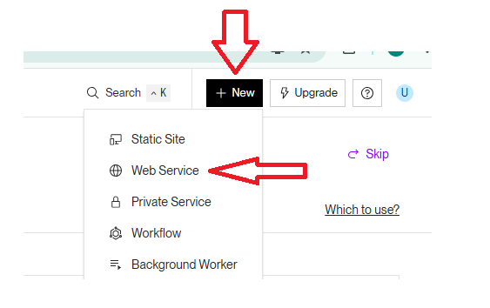

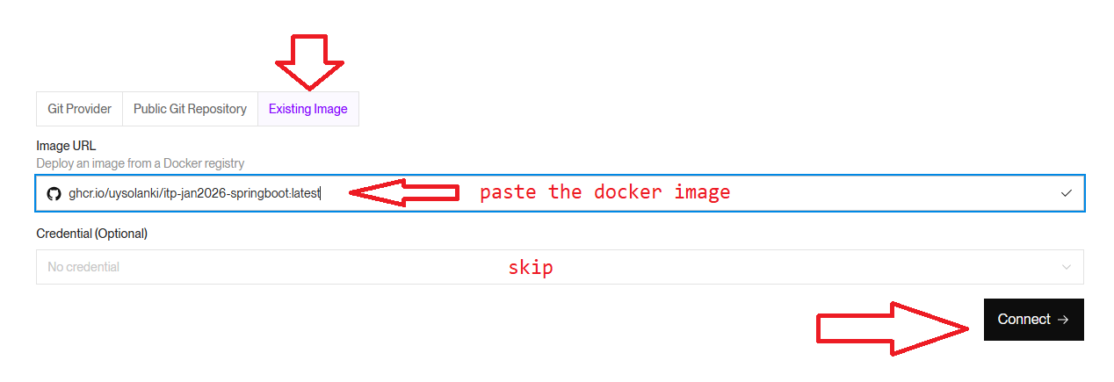

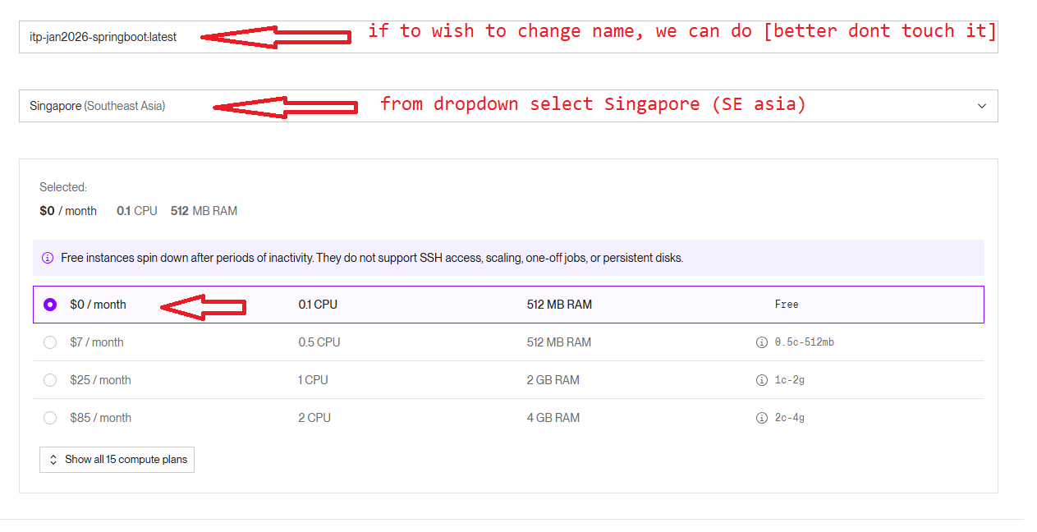

On the same page Scroll down to the Environment Variables section and add the following Key/Value pairs:
PORT = 8080
SERVER_PORT = 8080
SPRING_DATASOURCE_URL = jdbc:postgresql://aws-0-ap-southeast-1.pooler.supabase.com:5432/postgres?sslmode=require
SPRING_DATASOURCE_USERNAME = postgres.ylvamnubisxnkydxkxzk
SPRING_DATASOURCE_PASSWORD = <Your-Supabase-DB-Password>
SPRING_DATASOURCE_DRIVER_CLASS_NAME = org.postgresql.Driver
SUPABASE_URL = https://ylvamnubisxnkydxkxzk.supabase.co
SUPABASE_PUBLISHABLE_KEY = sb_publishable_ogJ4TeLWqgi0tAuOonaL3g_mByDKABZ
SUPABASE_SECRET_KEY = <Your-Supabase-Secret-Key>
SUPABASE_JWKS_URL = https://ylvamnubisxnkydxkxzk.supabase.co/auth/v1/.well-known/jwks.json
JWT_SECRET = pooja123_pranav987_pratik568_sanskar765_itpreneurpune_fullstack_development

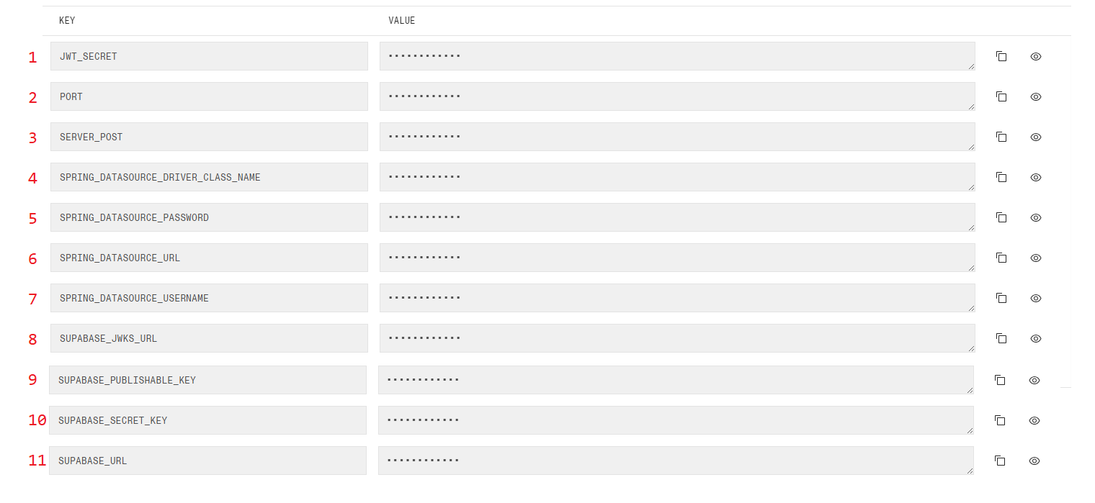

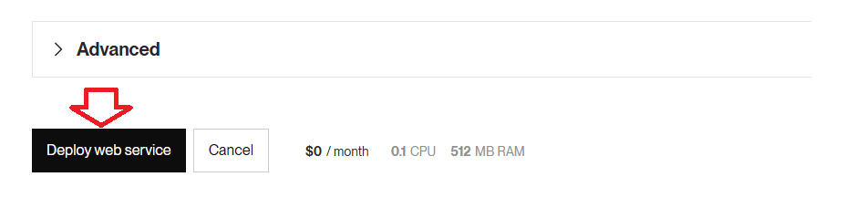

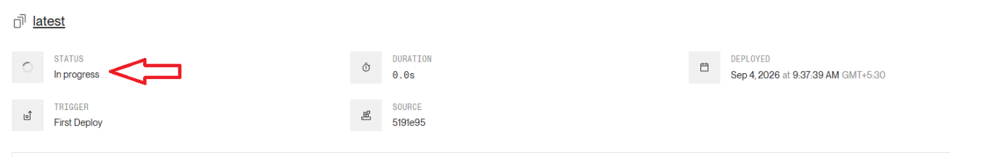

Conclusion
- Database: Hosted on Supabase (PostgreSQL) using the IPv4 Session Pooler.
- Backend: Built with Maven, packaged with Docker, automated via GitHub Actions (ghcr.io), and hosted live on Render.

Render url will be visible in the logs
